Project Report

On

Cab fare Prediction

Rahul Manikrao Meshram

INDEX

- Introduction
1.1 Problem Statement
1.2 Data

- Methodology
Pre-Processing
Modelling
Model Selection
- Pre-Processing
3.1 Data exploration and Cleaning (Missing Values and Outliers)
3.2 Creating some new variables from the given variables
3.3 Selection of variables
3.4 Some more data exploration
Dependent and Independent Variables
Uniqueness of Variables
Dividing the variables categories
3.5 Feature Scaling
4. Modelling
4.1 Linear Regression
4.2 Decision Tree
4.3 Random Forest
4.5 Hyper Parameters Tunings for optimizing the results
5.Conclusion
5.1 Model Evaluation
5.2 Model Selection
5.3 Some Visualization facts
Chapter 1
Introduction
Now a day’s cab rental services are expanding with the multiplier rate. The ease of using the services
and flexibility gives their customer a great experience with competitive prices.
1.1 Problem Statement
You are a cab rental start-up company. You have successfully run the pilot project and now want to launch your cab service across the country. You have collected the historical data from your pilot project and now have a requirement to apply analytics for fare prediction. You need to design a system that predicts the fare amount for a cab ride in the city.
1.2 Data
Understanding of data is the very first and important step in the process of finding solution of any business problem. Here in our case our company has provided a data set with following features, we need to go through each and every variable of it to understand and for better functioning. Size of Dataset Provided: - 16067 rows, 7 Columns (including dependent variable)
Missing Values: Yes
Outliers Presented: Yes
Below mentioned is a list of all the variable names with their meanings:
Variables Description
fare_amount --Fare amount
pickup_datetime --Cab pickup date with time
pickup_longitude-- Pickup location longitude
pickup_latitude --Pickup location latitude
dropoff_longitude --Drop location longitude
dropoff_latitude-- Drop location latitude
passenger_count --Number of passengers sitting in the cab

Chapter 2
Methodology
➢ Pre-Processing
When we required to build a predictive model, we require to look and manipulate the data before we start modelling which includes multiple preprocessing steps such as exploring the data, cleaning the data as well as visualizing the data through graph and plots, all these steps is combined under one shed which is Exploratory Data Analysis, which includes following steps:
• Data exploration and Cleaning
• Missing values treament
• Outlier Analysis
• Feature Selection
• Features Scaling
o Skewness and Log transformation
• Visualization
➢ Modelling
Once all the Pre-Processing steps has been done on our data set, we will now further move to our next step which is modelling. Modelling plays an important role to find out the good inferences from the data. Choice of models depends upon the problem statement and data set. As per our problem statement and dataset, we will try some models on our preprocessed data and post comparing the output results we will select the best suitable model for our problem. As per our data set following models need to be tested:
• Linear regression
• Decision Tree
• Random forest,
• Gradient Boosting
❖ We have also used hyper parameter tunings to check the parameters on which our model runs best. Following are two techniques of hyper parameter tuning we have used: o Random Search CV
➢ Model Selection
The final step of our methodology will be the selection of the model based on the different output and results shown by different models. We have multiple parameters which we will study further in our report to test whether the model is suitable for our problem statement or not.
Chapter 3
Pre-Processing
3.1 Data exploration and Cleaning (Missing Values and Outliers)
The very first step which comes with any data science project is data exploration and cleaning which includes following points as per this project:
a. Separate the combined variables.
b. As we know we have some negative values in fare amount so we have to remove those values.
c. Passenger count would be max 6 if it is a SUV vehicle not more than that. We have to remove the rows having passengers counts more than 6 and less than 1.
d. There are some outlier figures in the fare (like top 3 values) so we need to remove those.
e. Latitudes range from -90 to 90. Longitudes range from -180 to 180. We need to remove the rows if any latitude and longitude lies beyond the ranges.
3.2 Creating some new variables from the given variables.
Here in our data set our variable name pickup_datetime contains date and time for pickup. So we tried to extract some important variables from pickup_datetime:
• Year
• Month
• Date
• Day of Week
• Hour
• Minute
. Second
Also, we tried to find out the distance using the haversine formula which says: The haversine formula determines the great-circle distance between two points on a sphere given their longitudes and latitudes. Important in navigation, it is a special case of a more general formula in
spherical trigonometry, the law of haversines, that relates the sides and angles of spherical triangles.

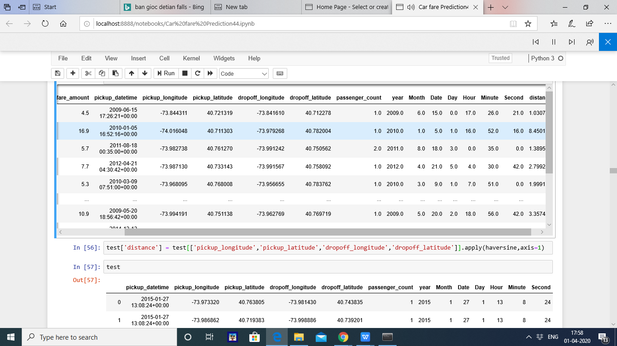

VariableNames Variable DataTypes
fare_amount | float64
passenger_count int64 | int64
year int64 | int64
Month int64 | int64
Date int64 | int64
Day | int64
Hour | int64
Distance | float64

dtype: object

3.4 Some more data exploration
In this report we are trying to predict the fare prices of a cab rental company. So here we have a data set
of 16067 observations with 8 variables including one dependent variable.
3.4.1 Below are the names of Independent variables:
passenger_count, year, Month, Date, Day of Week, Hour, distance
Our Dependent variable is: fare_amount
3.4.2 Uniqueness in Variable
We need to look at the unique number in the variables which help us to decide whether the variable is
categorical or numeric. So, by using python script ‘nunique’ we tried to find out the unique values in
each variable. We have also added the table below:
Variable Name Unique Counts
fare_amount 450
passenger_count 7
year 7
Month 12
Date 31
Day of Week 7
Hour 24
distance 15424
3.4.3 Dividing the variables into two categories basis their data types:
Continuous variables - 'fare_amount', 'distance'.
Categorical Variables - 'year', 'Month', 'Date', 'Day of Week', 'Hour',
'passenger_count'

3.5 Feature Scaling
Skewness is asymmetry in a statistical distribution, in which the curve appears distorted or skewed either to the left or to the right. Skewness can be quantified to define the extent to which a distribution differs from a normal distribution. Here we tried to show the skewness of our variables and we find that our target variable absenteeism in hours having is one sided skewed so by using log transform technique we tried to reduce the skewness of the same.
Below mentioned graphs shows the probability distribution plot to check distribution before log transformation:Below mentioned graphs shows the probability distribution plot to check distribution

distance
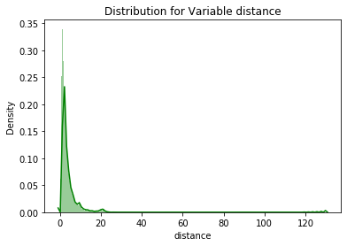

Fare_amount
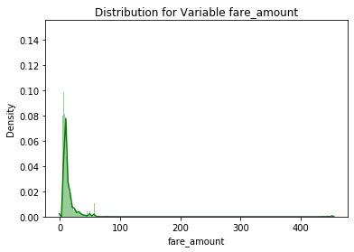

Below mentioned graphs shows the probability distribution plot to check distribution after log
transformation:
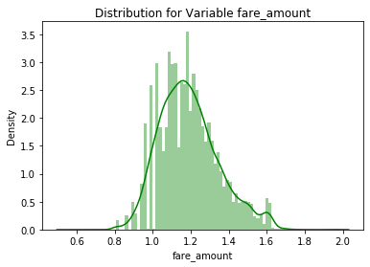

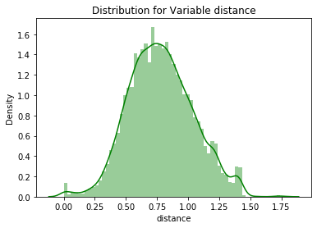
As our continuous variables appears to be normally distributed so we don’t need to use feature scaling techniques like normalization and standardization for the same.

Chapter 4
Modelling
After a thorough preprocessing, we will use some regression models on our processed data to predict the target variable. Following are the models which we have built –
Linear Regression
Decision Tree
Random Forest
Before running any model, we will split our data into two parts which is train and test data. Here in our case we have taken 80% of the data as our train data. Below is the snipped image of the split of train test.

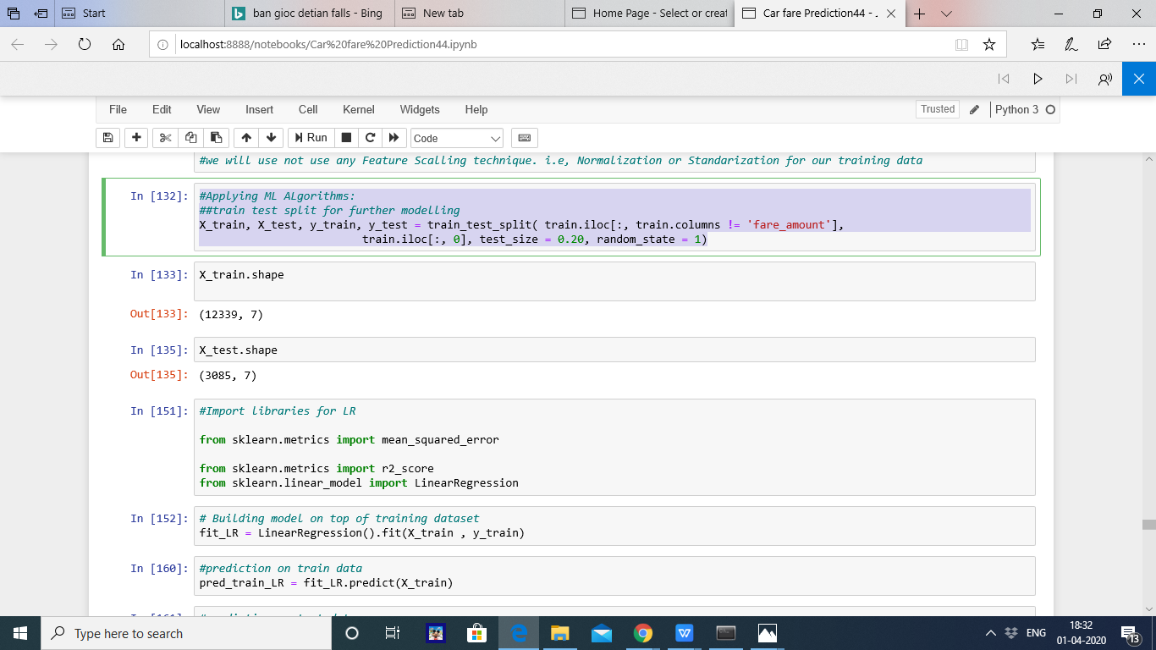

4.1 Linear Regression
Multiple linear regression is the most common form of linear regression analysis. Multiple regression is an extension of simple linear regression. It is used as a predictive analysis, when we want to predict the value of a variable based on the value of two or more other variables. The variable we want to predict is called the dependent variable (or sometimes, the outcome, target or criterion variable). Below is a screenshot of the model we build and its output:
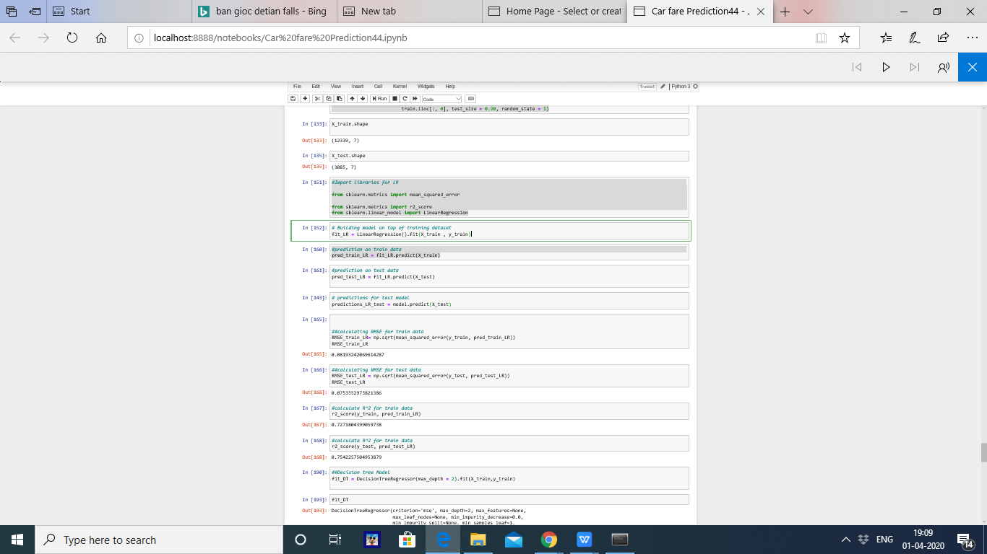

4.2 Decision Tree
A tree has many analogies in real life, and turns out that it has influenced a wide area of machine learning, covering both classification and regression. In decision analysis, a decision tree can be used to
visually and explicitly represent decisions and decision making. As the name goes, it uses a tree-like model of decisions. Below is the screen shot of the query we executed and the result shown, we will compare the results of each model in a combined table later on.
Decision Tree Algorithm



4.3 Random Forest
Random forests or random decision forests are an ensemble learning method for classification, regression and other task, that operate by constructing a multitude of decision trees at training time and outputting the class that is the mode of the classes (classification) or mean prediction (regression) of the individual trees. Random decision forests correct for decision trees' habit of overfitting to their training
set.
To say it in simple words: Random forest builds multiple decision trees and merges them together to get a more accurate and stable prediction.
Below is a screenshot of the model we build and its output:

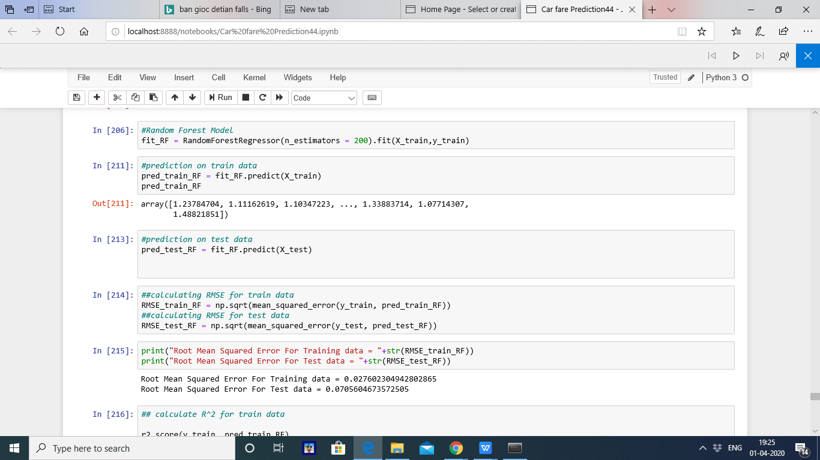

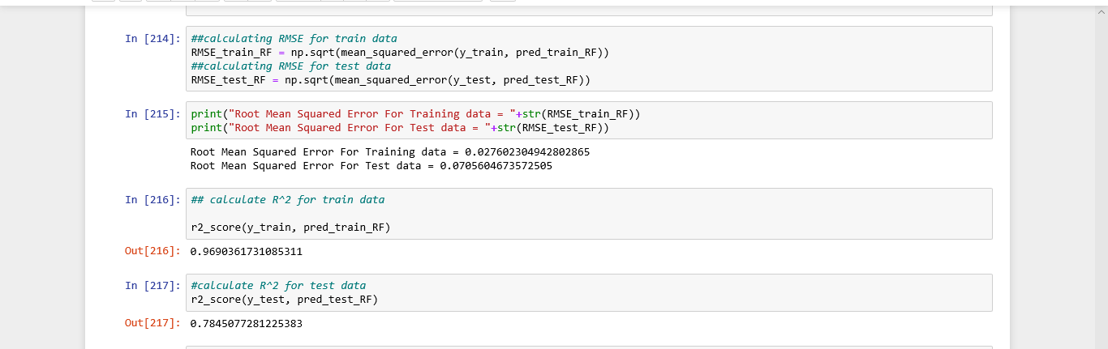

4.5 Hyper Parameters Tunings for optimizing the results
Model hyperparameters are set by the data scientist ahead of training and control implementation aspects of the model. The weights learned during training of a linear regression model are parameters while the number of trees in a random forest is a model hyperparameter because this is set by the data scientist. Hyperparameters can be thought of as model settings. These settings need to be tuned for each problem
because the best model hyperparameters for one particular dataset will not be the best across all datasets. The process of hyperparameter tuning (also called hyperparameter optimization) means finding the combination of hyperparameter values for a machine learning model that performs the best - as measured on a validation dataset - for a problem.Here we have used two hyper parameters tuning techniques
➢ Grid Search CV

. Grid Search CV: This algorithm set up a grid of hyperparameter values and for each combination, train a model and score on the validation data. In this approach, every single combination of hyperparameters values is tried which can be very inefficient.

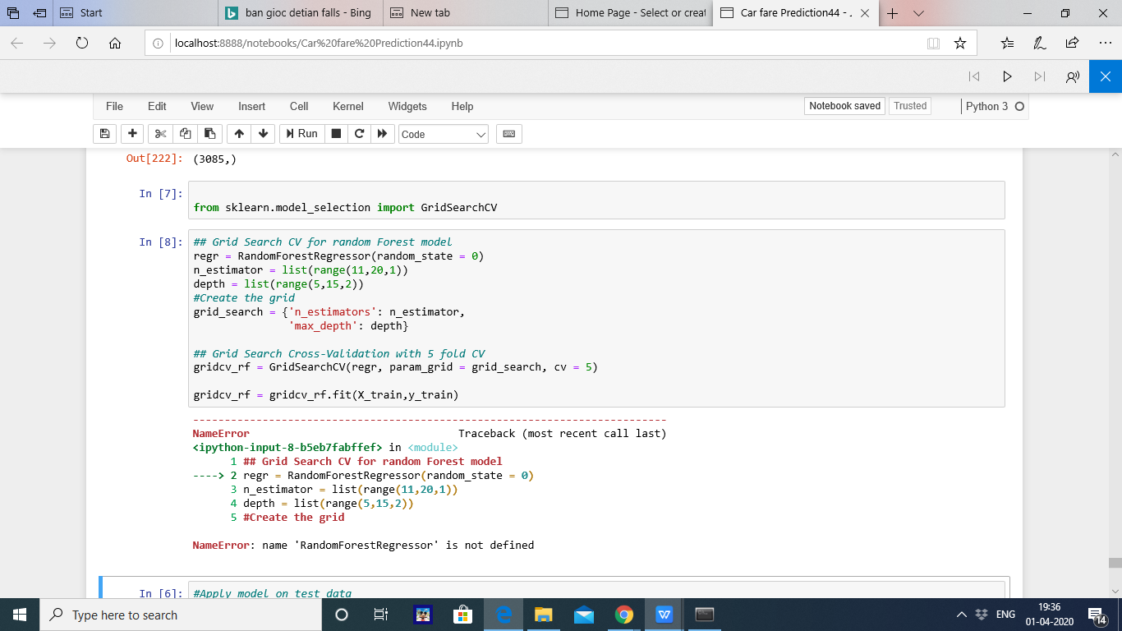

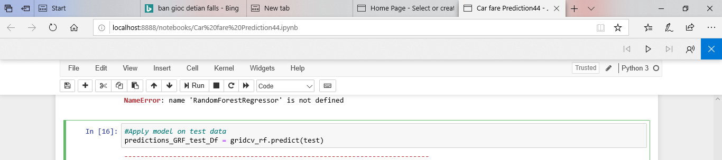

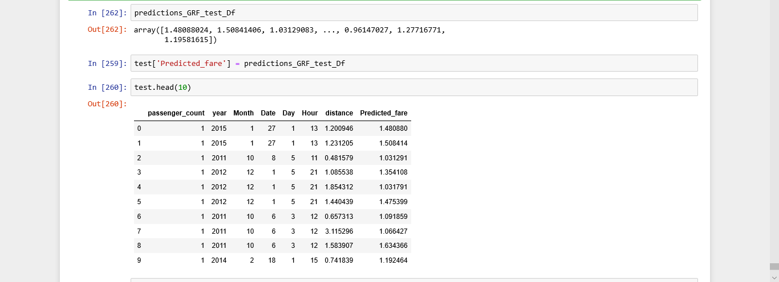

Chapter 5
Conclusion
5.1 Model Evaluation
The main concept of looking at what is called residuals or difference between our predictions f(x[I,]) and actual outcomes y[i].
In general, most data scientists use two methods to evaluate the performance of the model:
I. RMSE (Root Mean Square Error): is a frequently used measure of the difference between values predicted by a model and the values actually observed from the environment that is being modelled.
II. R Squared(R^2): is a statistical measure of how close the data are to the fitted regression line. It is also known as the coefficient of determination, or the coefficient of multiple determination for multiple regression. In other words, we can say it explains as to how much of the variance of the target variable is explained.
III. We have shown both train and test data results, the main reason behind showing both the results is to check whether our data is overfitted or not. Below table shows the model results before applying hyper tuning:
Model Name RMSE R Squared
Train Test Train Test
`Linear Regression 0.081 0.075 0.72 0.75
Decision Tree 0.086 0.083 0.69 0.69
Random Forest model 0.02 0.07 0.96 0.78

Model Selection
On the basis RMSE and R Squared results a good model should have least RMSE and max R Squared
value. So, from above tables we can see:
• From the observation of all RMSE Value and R-Squared Value we have concluded that,
• Both the models- Gradient Boosting Default and Random Forest perform comparatively well
while comparing their RMSE and R-Squared value.
• After this, I chose Random Forest CV and Grid Search CV to apply cross validation technique
and see changes brought about by that.
• After applying tunings Random forest model shows best results
• So finally, we can say that Random forest model is the best method to make prediction for this project with highest explained variance of the target variables and lowest error chances with parameter tuning technique Grid Search CV.
Finally, I used this method to predict the target variable for the test data file shared in the problem statement. Results that I found are attached with my submissions.

5.3 Some more visualization facts:
1. Number of passengers and fare
We can see in below graph that single passengers are the most frequent travelers, and the highest fare
also seems to come from cabs which carry just 1 passenger.

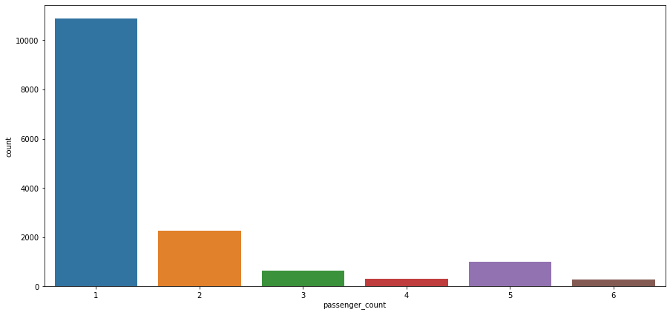

2. Date of month and fares
The fares throughout the month mostly seem uniform.

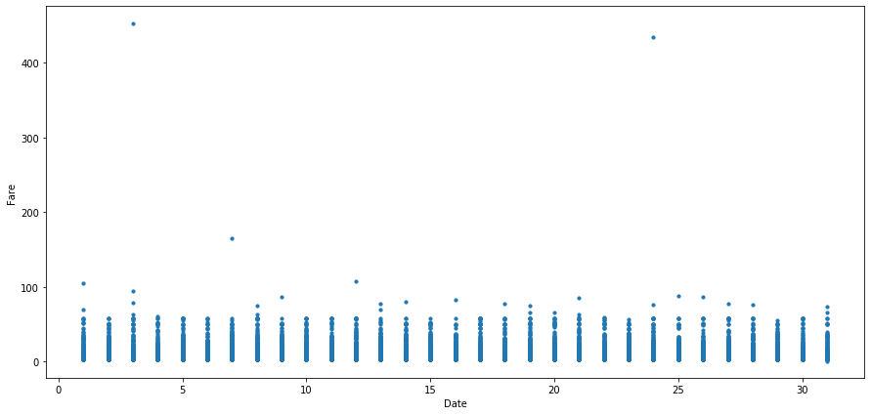
3. Hours and Fares
• During hours 6 PM to 11PM the frequency of cab boarding is very due to peak hours
• Fare prices during 2PM to 8PM is bit high compared to all other time might be due to high demands.

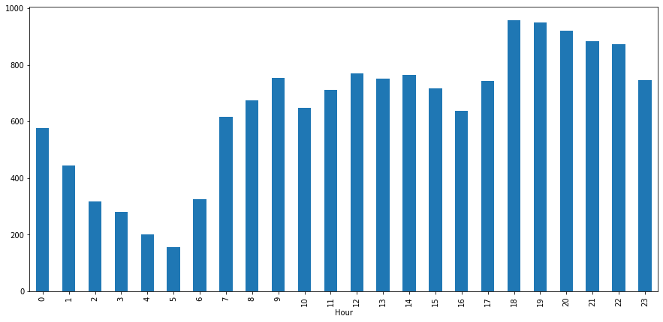
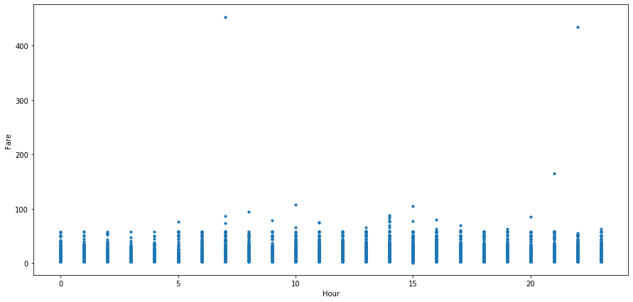

4. Week Day and fare
• Cab fare is high on Friday, Saturday and Monday, may be during weekend and first day of the working day they charge high fares because of high demands of cabs.
5. Impact of Day on the Number of Cab rides :
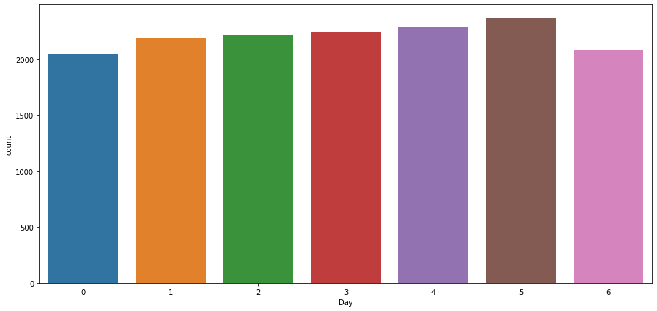
Observation : The day of the week does not seem to have much influence on the number of cabs ride

End report :::::

References
1. For Data Cleaning and Model Development -
https://edwisor.com/career-data-scientist
2. For other code related queries -
https://www.analyticsvidhya.com/blog/2016/03/practical-guide-principal-component-analysis
python/
3. For Visualization –
https://www.udemy.com/python-for-data-science-and-machine-learning-bootcamp/
4. https://towardsdatascience.com/
5. https://stackoverflow.com/

Appendix

- Code

rm(list = ls())
setwd("D:/Python/Car Prediction/R code")

# loading datasets
train = read.csv(choose.files(), header = T)
test = read.csv(choose.files(), header = T)
# Structure of data
str(train)
str(test)
summary(train)
summary(test)
# converting the features in the required data types.
train$fare_amount = as.numeric(as.character(train$fare_amount))
train$passenger_count=round(train$passenger_count)
########### data cleaning #############
# fare amount cannot be less than one
# considring fare amount 453 as max and removing all the fare amount greater than 453, as chances are very less of fare amount having 4000 and 5000 ...etc
train[which(train$fare_amount < 1 ),]
nrow(train[which(train$fare_amount < 1 ),]) # to show the count i.e.,5
train = train[-which(train$fare_amount < 1 ),] # removing those values.
train[which(train$fare_amount>453),]
nrow(train[which(train$fare_amount >453 ),]) # to show the count i.e., 2
train = train[-which(train$fare_amount >453 ),] # removing those values.
# passenger count cannot be Zero
# even if we consider suv max seat is 6, so removing passenger count greater than 6.
train[which(train$passenger_count < 1 ),]
nrow(train[which(train$passenger_count < 1 ),]) # to show count, that is 58
train=train[-which(train$passenger_count < 1 ),] # removing the values
train[which(train$passenger_count >6 ),]
nrow(train[which(train$passenger_count >6 ),]) # to show count, that is 20
train=train[-which(train$passenger_count >6 ),] # removing the values
# Latitudes range from -90 to 90.Longitudes range from -180 to 180.
# Removing which does not satisfy these ranges.
print(paste('pickup_longitude above 180=',nrow(train[which(train$pickup_longitude >180 ),])))
print(paste('pickup_longitude above -180=',nrow(train[which(train$pickup_longitude < -180 ),])))
print(paste('pickup_latitude above 90=',nrow(train[which(train$pickup_latitude > 90 ),])))
print(paste('pickup_latitude above -90=',nrow(train[which(train$pickup_latitude < -90 ),])))
print(paste('dropoff_longitude above 180=',nrow(train[which(train$dropoff_longitude > 180 ),])))
print(paste('dropoff_longitude above -180=',nrow(train[which(train$dropoff_longitude < -180 ),])))
print(paste('dropoff_latitude above -90=',nrow(train[which(train$dropoff_latitude < -90 ),])))
print(paste('dropoff_latitude above 90=',nrow(train[which(train$dropoff_latitude > 90 ),])))
train = train[-which(train$pickup_latitude > 90),] # removing one data point
# Also we will see if there are any values equal to 0.
nrow(train[which(train$pickup_longitude == 0 ),])
nrow(train[which(train$pickup_latitude == 0 ),])
nrow(train[which(train$dropoff_longitude == 0 ),])
nrow(train[which(train$pickup_latitude == 0 ),])
# removing those data points.
train=train[-which(train$pickup_longitude == 0 ),]
train=train[-which(train$dropoff_longitude == 0),]
sum(is.na(train))
sum(is.na(test))
train=na.omit(train)
sum(is.na(train))
# deriving the new features using pickup_datetime and coordinated provided.
# new features will be year,month,day_of_week,hour
# Convert pickup_datetime from factor to date time
train$pickup_datetime=as.Date(train$pickup_datetime)
pickup_time = strptime(train$pickup_datetime,format='%Y-%m-%d %H:%M:%S UTC')
train$date = as.integer(format(train$pickup_date,"%d"))# Monday = 1
train$mnth = as.integer(format(train$pickup_date,"%m"))
train$yr = as.integer(format(train$pickup_date,"%Y"))
#train$min = as.integer(format(train$pickup_date,"%M"))
#train$day=as.integer(as.POSIXct(train$pickup_datetime),abbreviate=F)
# for test data set.
test$pickup_datetime=as.Date(test$pickup_datetime)
pickup_time = strptime(test$pickup_datetime,format='%Y-%m-%d %H:%M:%S UTC')
test$date = as.integer(format(test$pickup_date,"%d"))# Monday = 1
test$mnth = as.integer(format(test$pickup_date,"%m"))
test$yr = as.integer(format(test$pickup_date,"%Y"))
#test$min = as.integer(format(test$pickup_date,"%M"))

# outlier
library(ggplot2)
pl1 = ggplot(train,aes(x = factor(passenger_count),y = fare_amount))
pl1 + geom_boxplot(outlier.colour="red", fill = "grey" ,outlier.shape=18,outlier.size=1, notch=FALSE)+ylim(0,100)
# deriving the new feature, distance from the given coordinates.
library(geosphere)

train$dist= distHaversine(cbind(train$pickup_longitude, train$pickup_latitude), cbind(train$dropoff_longitude,train$dropoff_latitude))
#the output is in metres, Change it to kms
train$dist=as.numeric(train$dist)/1000
test$dist= distHaversine(cbind(test$pickup_longitude, test$pickup_latitude), cbind(test$dropoff_longitude,test$dropoff_latitude))
#the output is in metres, Change it to kms
test$dist=as.numeric(test$dist)/1000
# removing the features, which were used to create new features.
train = subset(train,select = -c(pickup_longitude,pickup_latitude,dropoff_longitude,dropoff_latitude,pickup_datetime))
test = subset(test,select = -c(pickup_longitude,pickup_latitude,dropoff_longitude,dropoff_latitude,pickup_datetime))
str(train)
summary(train)
nrow(train[which(train$dist ==0 ),])
nrow(test[which(test$dist==0 ),])
nrow(train[which(train$dist >130 ),]) # considering the distance 130 as max and considering rest as outlier.
nrow(test[which(test$dist >130 ),])
# removing the data points by considering the above conditions,
train=train[-which(train$dist ==0 ),]
train=train[-which(train$dist >130 ),]
test=test[-which(test$dist ==0 ),]
# feature selection
numeric_index = sapply(train,is.numeric) #selecting only numeric
numeric_data = train[,numeric_index]
cnames = colnames(numeric_data)
#Correlation analysis for numeric variables
library(corrgram)
corrgram(train[,numeric_index],upper.panel=panel.pie, main = "Correlation Plot")
#removing date
# pickup_weekdat has p value greater than 0.05
train = subset(train,select=-date)
#remove from test set
test = subset(test,select=-date)
library(car)
library(MASS)
qqPlot(train$fare_amount) # qqPlot, it has a x values derived from gaussian distribution, if data is distributed normally then the sorted data points should lie very close to the solid reference line
truehist(train$fare_amount) # truehist() scales the counts to give an estimate of the probability density.
lines(density(train$fare_amount)) # lines() and density() functions to overlay a density plot on histogram
d=density(train$fare_amount)
plot(d,main="distribution")
polygon(d,col="green",border="red")

D=density(train$dist)
plot(D,main="distribution")
polygon(D,col="green",border="red")

A=density(test$dist)
plot(A,main="distribution")
polygon(A,col="black",border="red")
#Normalisation
# log transformation.
train$fare_amount=log1p(train$fare_amount)
test$dist=log1p(test$dist)
train$dist=log1p(train$dist)
d=density(train$fare_amount)
plot(d,main="distribution")
polygon(d,col="green",border="red")
D=density(train$dist)
plot(D,main="distribution")
polygon(D,col="red",border="black")
A=density(test$dist)
plot(A,main="distribution")
polygon(A,col="black",border="red")
print('fare_amount')
train[,'fare_amount'] = (train[,'fare_amount'] - min(train[,'fare_amount']))/
(max(train[,'fare_amount'] - min(train[,'fare_amount'])))
train[,'dist'] = (train[,'dist'] - min(train[,'dist']))/
(max(train[,'dist'] - min(train[,'dist'])))
test[,'dist'] = (test[,'dist'] - min(test[,'dist']))/
(max(test[,'dist'] - min(test[,'dist'])))
###check multicollearity
library(usdm)
vif(train[,-1])
vifcor(train[,-1], th = 0.9)
#No variable from the 4 input variables has collinearity problem.
#The linear correlation coefficients ranges between:
#min correlation ( mnth ~ passenger_count ): -0.001868147
#max correlation ( yr ~ mnth ): -0.1091115

# ---------- VIFs of the remained variables --------
# Variables VIF
# 1 passenger_count 1.000583
# 2 mnth 1.012072
# 3 yr 1.012184
# 4 distance 1.000681

## to make sure that we dont have any missing values
sum(is.na(train))
train=na.omit(train)
# model building
#create sampling and divide data into train and test
set.seed(123)
train_index = sample(1:nrow(train), 0.8 * nrow(train))

train1 = train[train_index,]#do not add column if already removed
test1 = train[-train_index,]#do not add column if already removed
#################Decision Tree#####################################
MAPE = function(y, yhat){
mean(abs((y - yhat)/y*100))
}
library(rpart)
fit = rpart(fare_amount ~. , data = train1, method = "anova", minsplit=5)

summary(fit)
predictions_DT = predict(fit, test1[,-1])

MAPE(test1[,1], predictions_DT)

write.csv(predictions_DT, "DT_R_PRed8.csv", row.names = F)

#Error 12.94
#Accuracy 87.06

# Rndom forest
library(randomForest)
RF_model = randomForest(fare_amount ~. , train1, importance = TRUE, ntree=100)
RF_Predictions = predict(RF_model, test1[,-1])

MAPE(test1[,1], RF_Predictions)

#error 12.69 for n=100
#accuracy = 87.31
# Linear model####
lm_model = lm(fare_amount ~. , data = train1)
summary(lm_model)

predictions_LR = predict(lm_model, test1[,-1])
MAPE(test1[,1], predictions_LR)

#error 13.55789
#Accuracy 86.44211

###Predict test data using random forest model

# Create the target variable
test$fare_amount=0
test= test[,c(1,2,3,4,5)]

RF_Predictions = predict(RF_model, test1[,-1])
RF_test=predict(RF_model, test[,-5])
write.csv(RF_test, "RF_R_PRed8.csv", row.names = F)

